**How to make a Rain stick: pg. 1**

**Materials:**

* **Paper towel rolls**
* **Tape**
* **Construction paper**
* **Scissors**
* **Markers**
* **Popcorn kernels (if no popcorn kernels, old buttons, beads, anything to make sound in the paper towel roll).**
* **optional – feathers for decoration!**

**Directions:**

1. **Use any type of decorations you want to add to your rain stick and decorate the entire paper towel roll. You can draw pictures on the paper towel roll with markers, glue buttons, tape feathers on the end of the roll, etc.**
2. **After you finish decorating your paper towel roll, you will cover the one end of the paper towel roll with construction paper and tape. Tape it tight so the popcorn kernels will not fall out when you add them into your rain stick.**
3. **After you added the popcorn kernels to the inside of your rain stick, tape the top of the paper towel tube with construction paper (the same as you did to the bottom of your rain stick).**
4. **Again, tape the paper tight so the kernels will not fall out of the rain stick.**
5. **Add your fetters or stripes of paper you cut out at the end of your rain stick.**

**How to make a Rain Stick pg.2**

1. **Now it’s time to make some “Rain Music”. Shake your rain stick with your hands and have some fun making some “Rain Music”.**

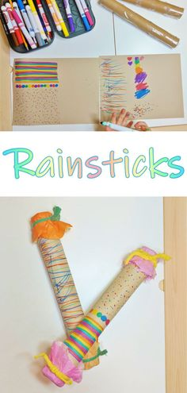

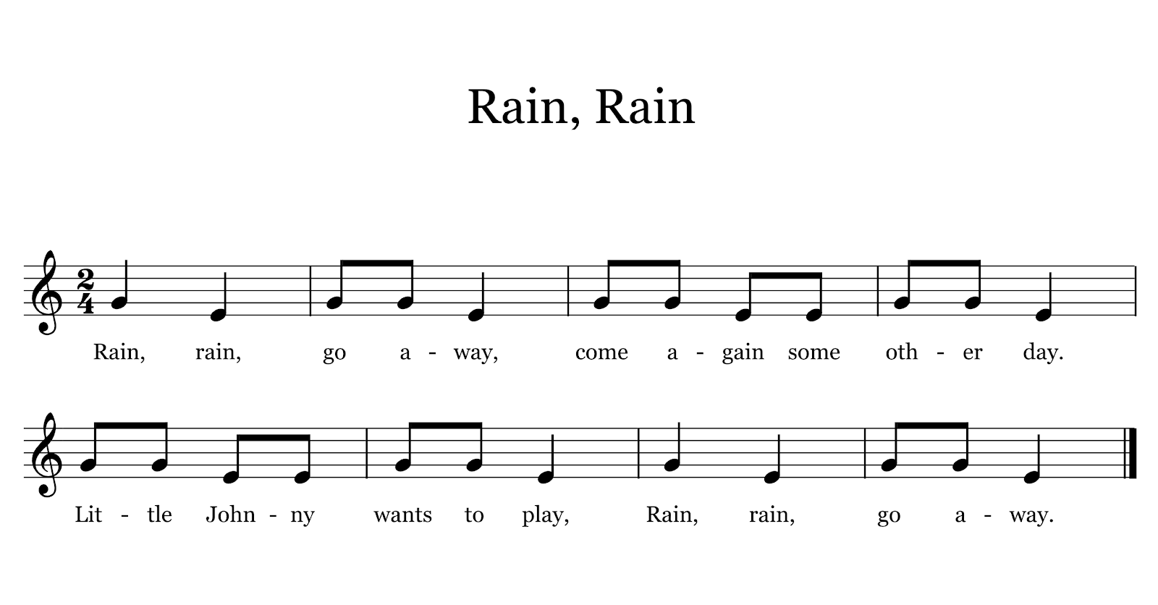

**How to Make a Rain Stick** **pg.4**

**Directions: Please reads the story below called “The Rain Stick a Fable”. You can find the story on “You Tube”. Type in the title of the story on “You Tube” and the read loud version of the story will appear.**

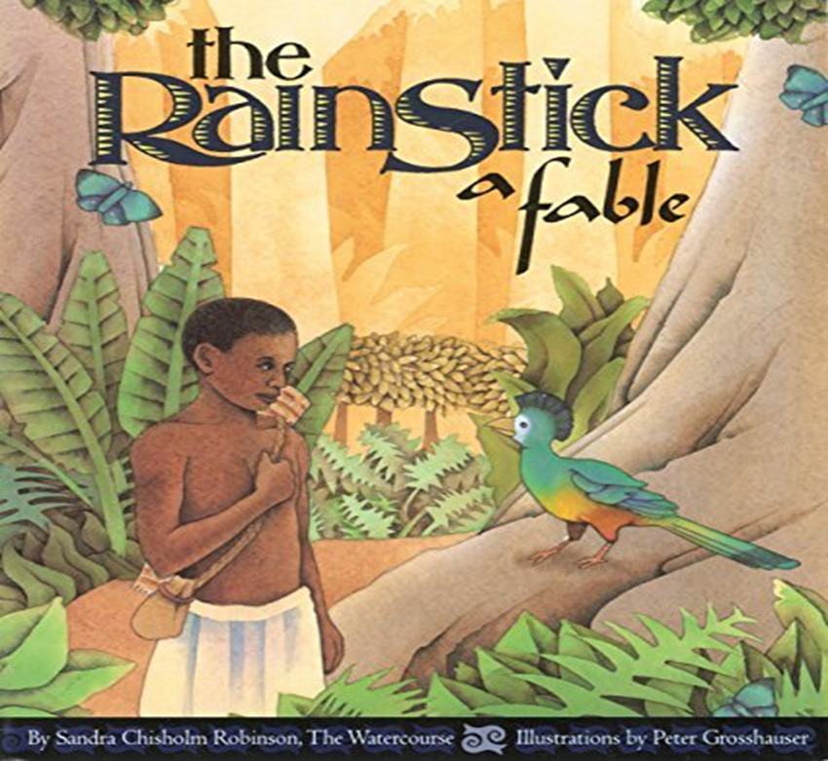

**Book Report**

**Name: Class:**

**Date:**

My Book Report Worksheet

|  |
| --- |
| Title of the book I read: |
| Author of the book I read: |
| Draw a picture of your favorite part of the book: |

